

**V-App Connect**

Remote Access User Guide

Contents

1. Preface 3

2. System Requirements/Important Information 3

2.1 Cisco SSL VPN Clientless System Requirements 3

2.2 Connecting to V-App connects: 3

3. CITRIX WORK SPACE APPLICATION 4

3.1 Citrix Workspace Application 4

3.2 Download & install Citrix Workspace 4

4. Launching applications from V-App Connect 6

4.1 How to launch applications from V-App Connect: 6

4.1.1 Main Tab 6

4.1.2 Other Tabs 6

5. Opening SAP application 7

5.1 Follow these steps for the first time you log on to SAP 7

5.2 Logging off the ExxonMobil network 7

## Preface

* This document will help you to understand the steps to connect V-APP CONNECT remotely. There are various ways to connect to Exxon-Mobile network to connect V-App via SYNCRUDE VPN gateway.

## System Requirements/Important Information

## Cisco SSL VPN Clientless System Requirements

Clientless SSL connections do not require any software to be installed on device. Below are the minimum requirements to connect to clientless SSL VPN.

* Client system with latest operating system and latest security patches installed.
* Latest web browsers (example google chrome, Mozilla Firefox and so on) should be installed with Active X enabled.
* Java (Sun JRE) should be installed with latest update.
* The computer must have access to the Internet through an Internet Service Provider (ISP), a company network, or a cellular (3G/4G) service.
* The firewall between your computer and the Internet needs to allow SSL VPN traffic to the Internet. If you have trouble connecting with these instructions, your firewall administrator needs to know that the VPN connection uses TCP 443 (SSL/ HTTPS) and UDP 443 (DTLS) and require that the rules allow outbound connection (i.e. from your network to ExxonMobil Syncrude VPN gateways).
* If you are using a Proxy Server on your Internet browser, do make sure the Citrix connection ports, TCP 1494 and UDP 1604, are allowed through your Proxy Server (Extending the SSL Tunnel Port Range).

## Connecting to V-App connects:

1. User needs type below URL from their web browser.
2. <https://diamond.syncrude.com/vappconnect>
3. Once connected to gateway, it will ask for user credentials for authentication and check the user authorization in network.
   * 1. 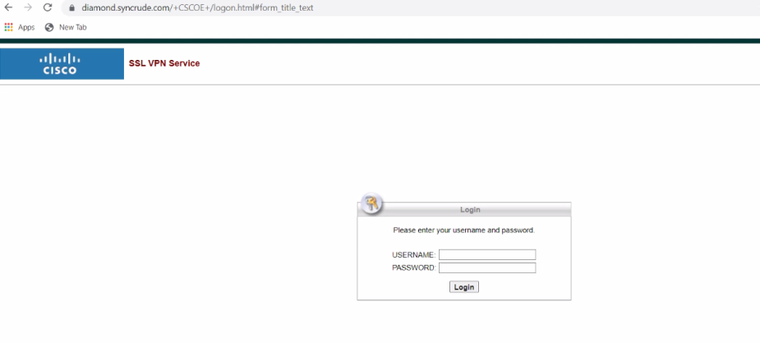
4. User needs to be following below document for successfully setup Secure Auth for generating credential.
   * 1. <file:///C:/Users/farsyed/AppData/Local/Microsoft/Windows/INetCache/Content.Outlook/KEPTDKT5/SecureAuth%20Software%20Token%20-%20Enrollment%20guide.pdf>

## CITRIX WORK SPACE APPLICATION

## Citrix Workspace Application

Citrix Workspace is a complete digital workspace solution that delivers secure access to the information, apps, and other content that is relevant to a person's role in your organization. To get connected to application, you need to install the Citrix Workspace application. User should have admin privilege to their system in order to install the application.

## Download & install Citrix Workspace

You need to be downloading Citrix Workspace app version 1810 saved it. Double click Citrix Workspace App. or above. Follow the steps below

1. Use below link to open Citrix Workspace website
   1. <https://www.citrix.com/downloads/workspace-app>
2. Select your preferred Workspace app and click to drop down arrow to open it.
   * 1. 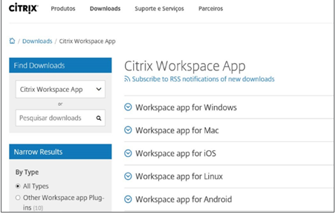
3. Now select the application your system type and click on the latest version
   * 1. 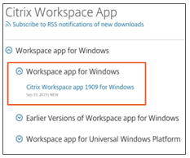
4. Click on the Citrix Work Space App button to download the application to your local system.
   * 1. <IMAGE>
5. Now you can find the downloaded file to your default download directory in your local system.
   * 1. 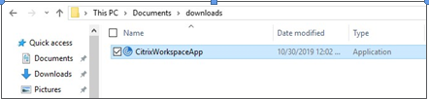
6. Now Double-click on application to proceed for installation
   * 1. 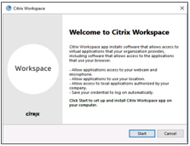
7. Select the radio button and click on next to proceed further (Mandatory to accept the license agreement).
   * 1. 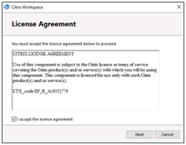
8. Now installation is successful. Click finish to exit.
   * 1. 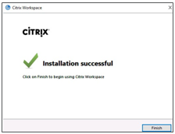

## Launching applications from V-App Connect

## How to launch applications from V-App Connect:

## Main Tab

This tab is your APPS tab where all your applications are displayed. Click on an application to launch.

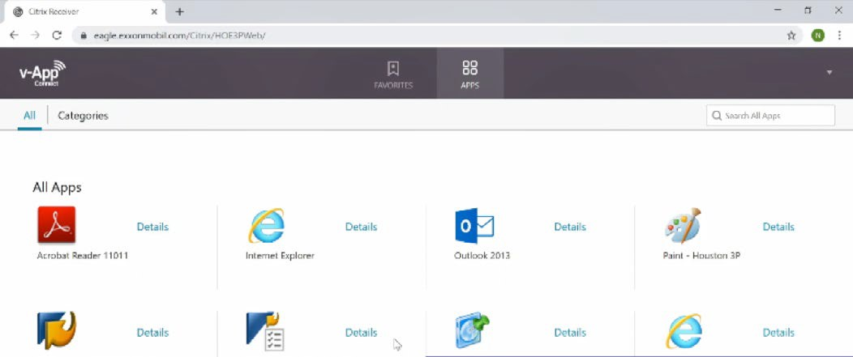

## Other Tabs

This tab is your FAVORITES tab where all of your favorite applications will show

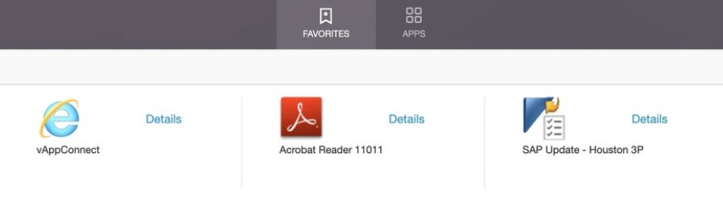

If enabled, you will see a DESKTOPS tab with the Landing Desktop application. This application allows you to access a virtual network.

NOTE: The applications may vary based on your user account.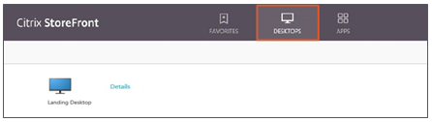

To launch the desktop application, Click on the application

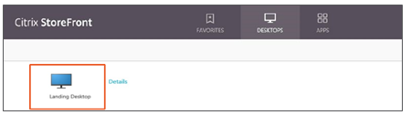

## Opening SAP application

## Follow these steps for the first time you log on to SAP

* Open the SAP update application. This app will run and close
* Open the SAP logon-SAPGUI application, this application may take little munity to load. If prompted click on permit all access.
* Select the appropriate SSO SAP connection

## Logging off the ExxonMobil network

* Right Click on the Citrix Workspace application icon located in your system tray.



* Select Connection Center

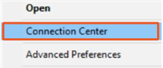

* Select the Server, click Log Off

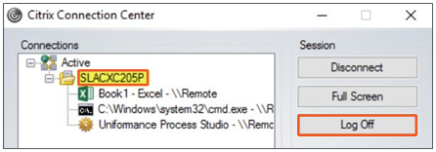

* NOTE: If your computer is idle for 16 hours, you will be automatically logged out from your applications and sessions, you will need to re-launch v-App Connect.